**TASK 4**

Simple **select query with a where clause on education column**.

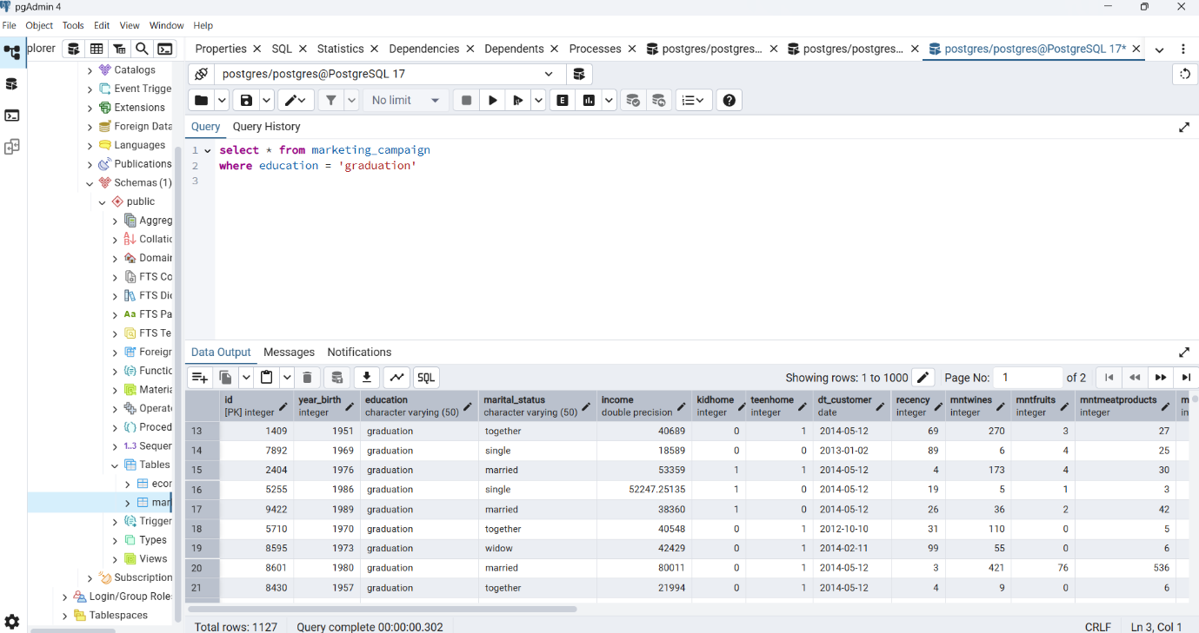

Select Query with where clause on education column and order by clause on year_birth column

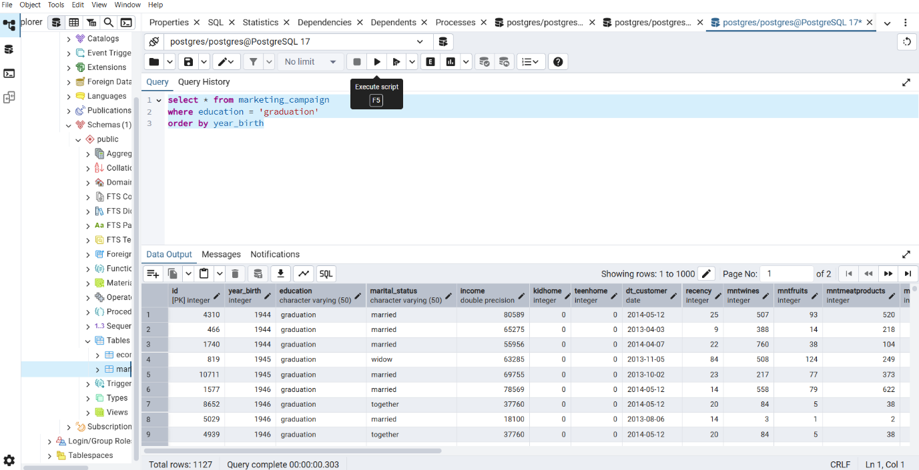

Select Query to show count for year_birth column with where clause on education column, grouped by year_birth column and order by clause on year_birth column

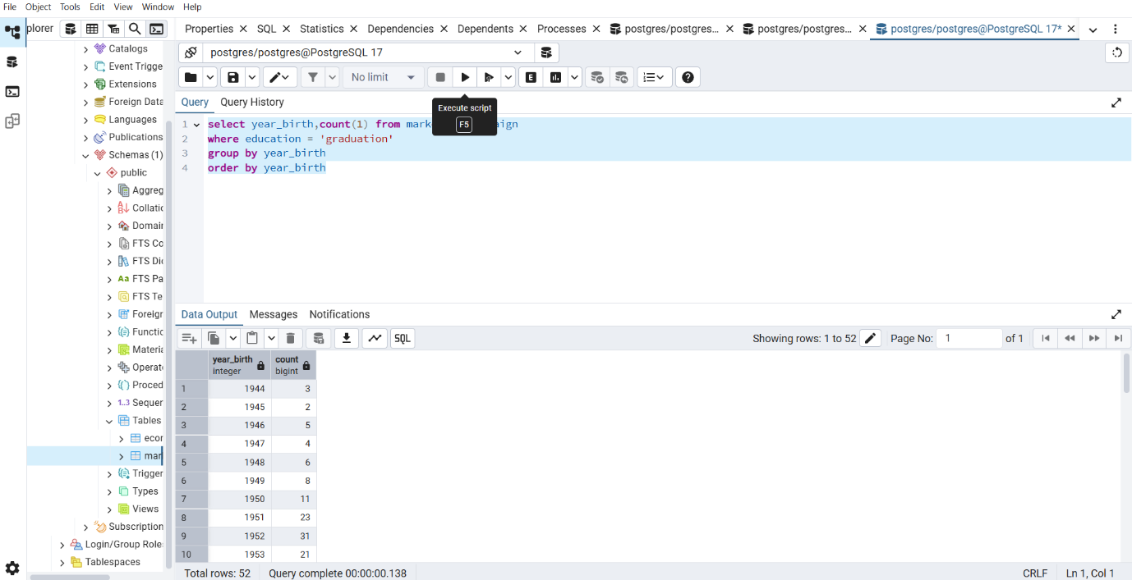

Select Query to show Income statistics

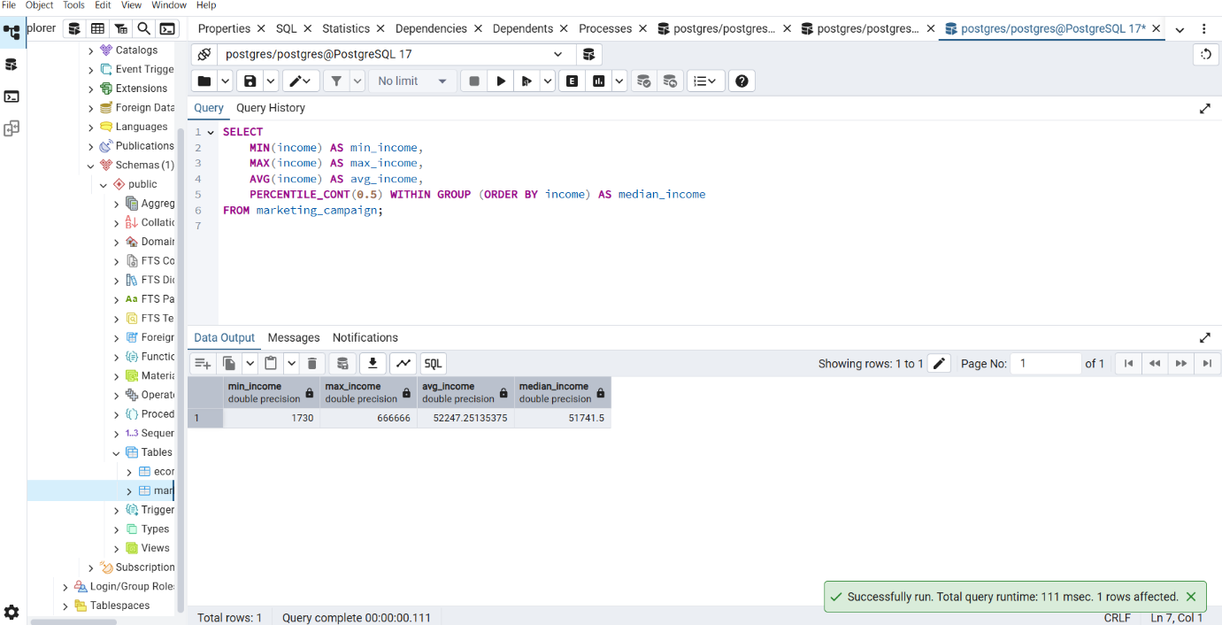

Select Query to show average spending by marital status

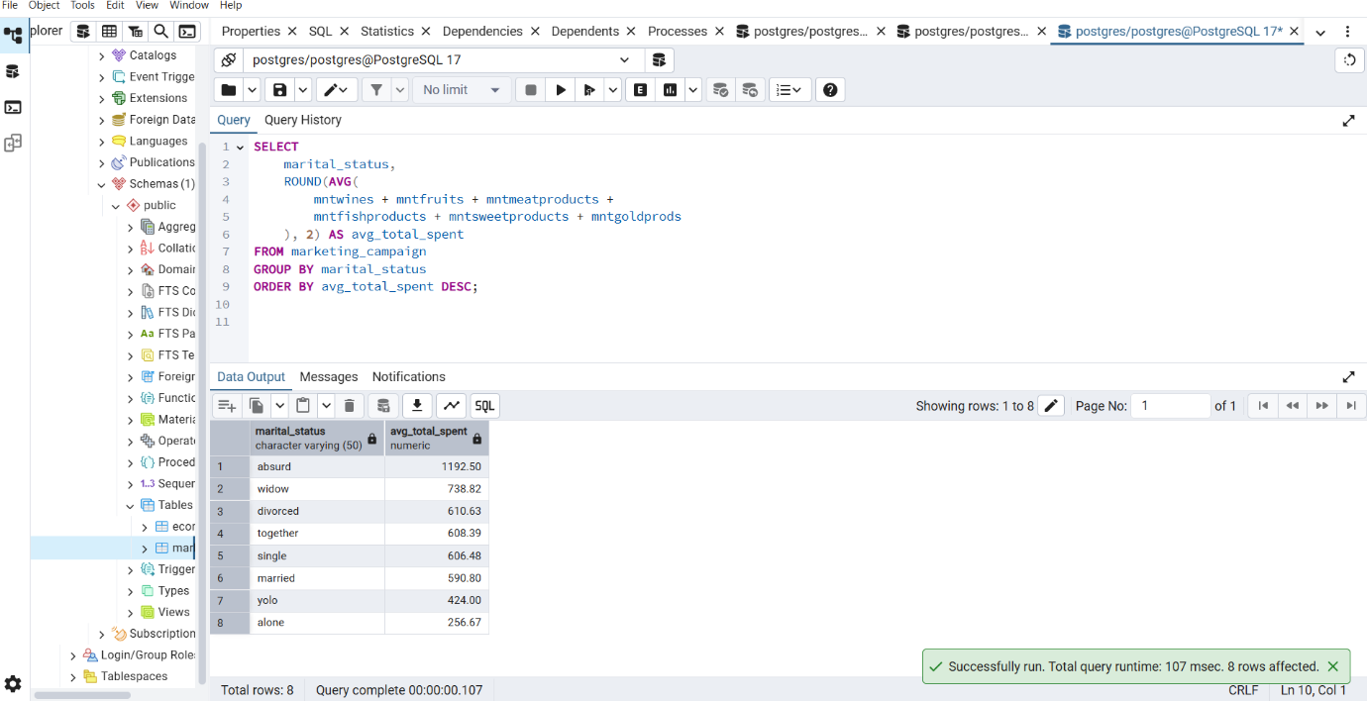

Select Query to show popularity of purchase channels

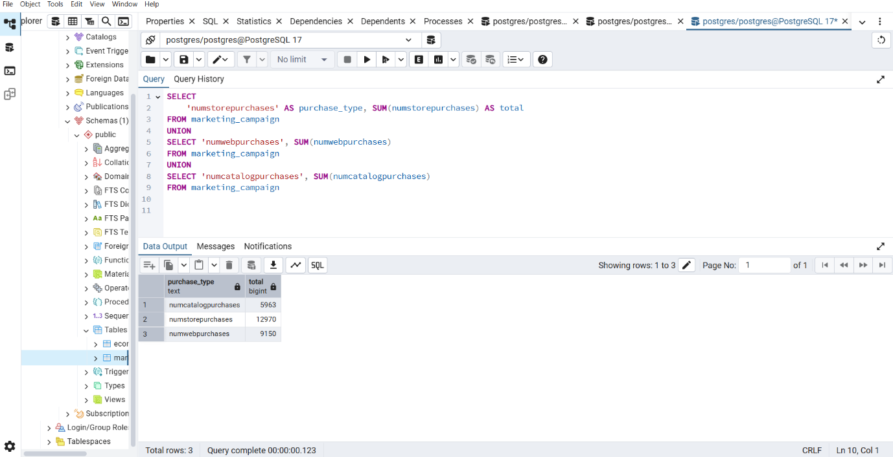

Select Query to show Potential Churn Risk

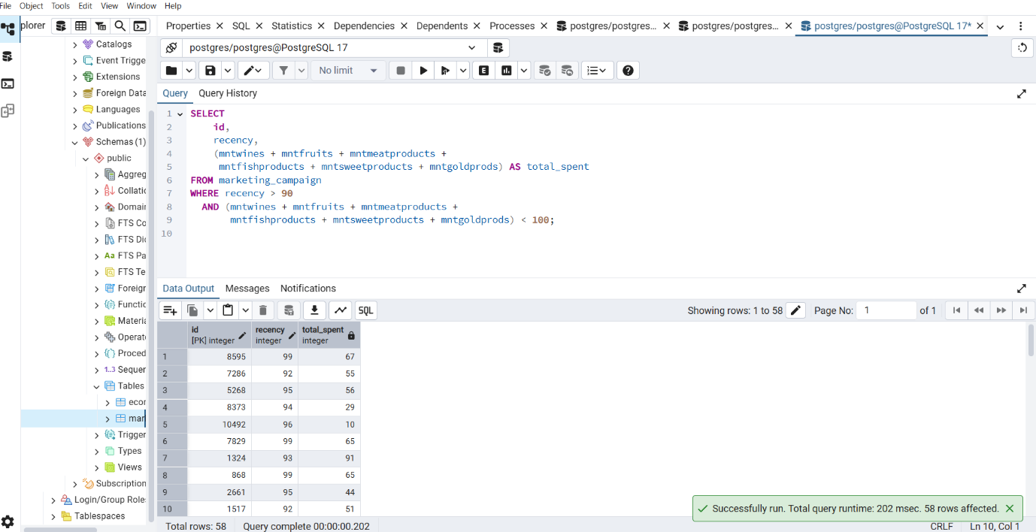

View query for Customer Profile

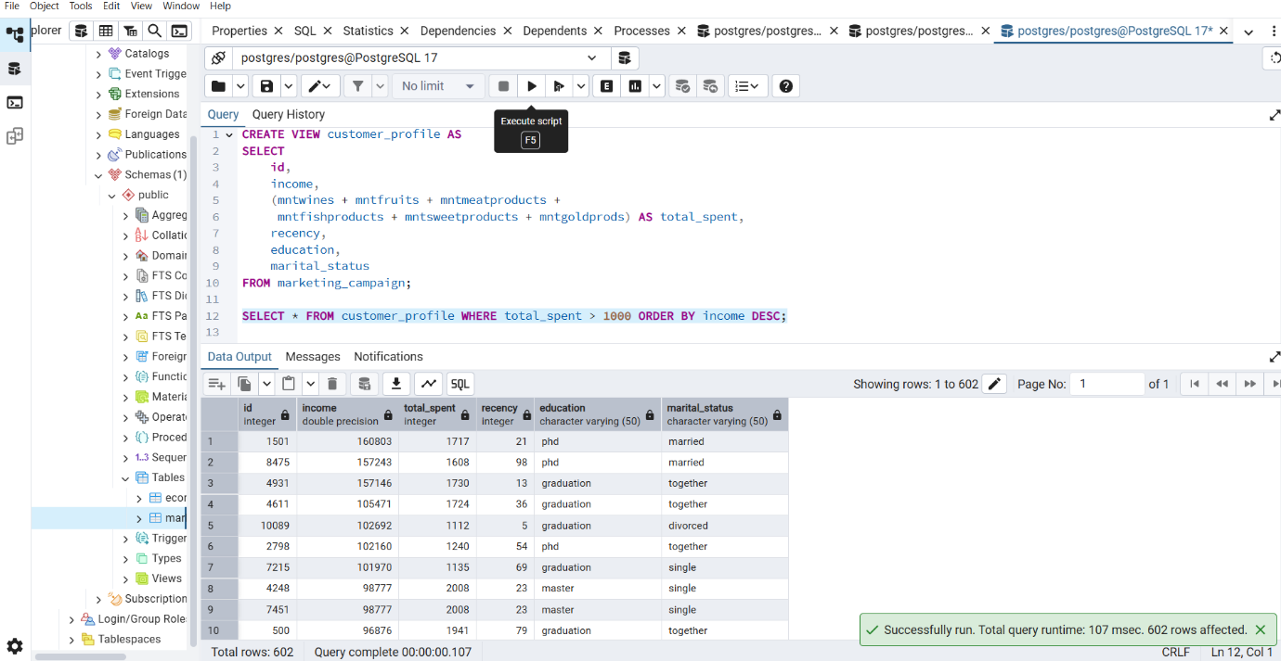

Indexes to improve query performance

